St. Petersburg Yacht Club
11 Central Avenue
St. Petersburg, Florida 33701
United States of America

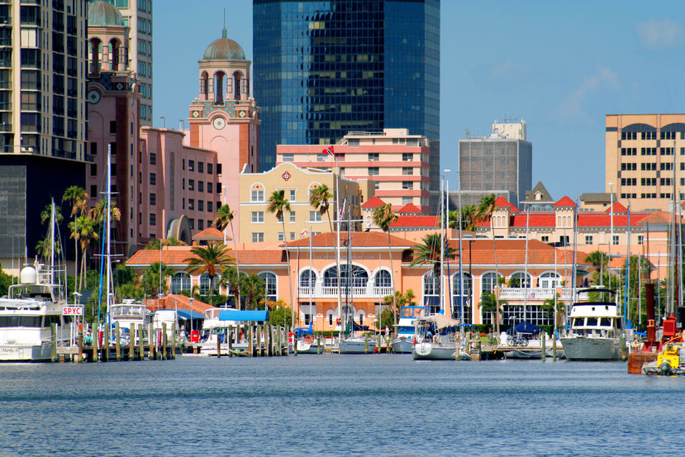

To: J-24 IJCA Representatives
From: St. Petersburg Yacht Club, St. Petersburg-Florida, USA
Subject: 2019 J 24 Worlds Championship
Date: November to April 2019 (Our Racing season)

The St. Petersburg Yacht Club would like to submit a bid to host the 2019 J-24 Worlds Racing Championship. We have read previous NOR for the World Championship and believe that the SPYC is exceptionally well qualified and meets the criteria stated in the request for bid. It would be an honor for us to be selected.

Organizing Authority:
St. Petersburg Yacht Club will be the Organizing Authority.
Contacts:
The primary contact is George Pennington, Regatta General Chairman, SPYC. He may be reached by telephone at 727-595-8206; by cell phone at 727-580-5431; and preferably via email at epennin09@earthlink.net. Regular mail may be sent to George at the St. Petersburg Yacht Club, 11 Central Avenue, St. Petersburg, FL, USA. Shawn Macking, the club’s Waterfront Director, may be reached at +1 727-822-3113 and via email at waterfront-director@spyc.org and at the same street address.
Dates:
Open to Venue dates selected by the IJCA November to April 2019.
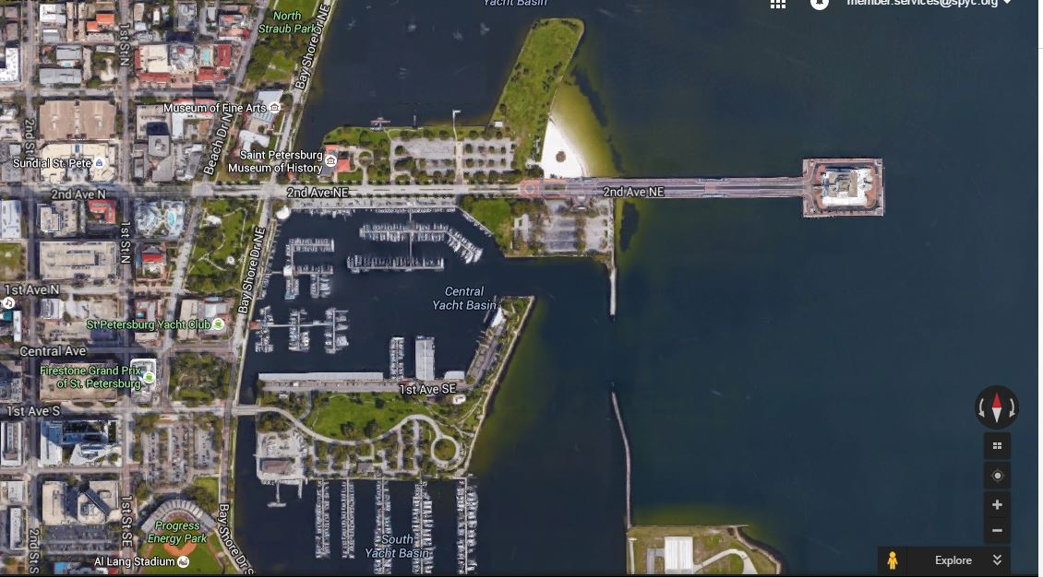
St. Petersburg, Florida, USA–Downtown Waterfront Area
#4
# 3
#1: St. Petersburg Yacht Club
#2: St. Petersburg Sailing Center
#3: St. Petersburg Pier
#4: Racing Area

Racing Area:
The racing area will be on Tampa Bay directly in front of the St. Petersburg Municipal Pier (shown on the right.)
The aerial photo below is of the St. Petersburg waterfront. The legend on the map shows the downtown and waterfront locations.
# 1
# 2

Venue: The venue will be St. Petersburg, Florida, USA.
Expected Weather Conditions:
70–75 degrees with temperatures exceeding 80 or below 50 degrees depending on dates.
Winds will vary, but are usually in the 6-12 knot range.
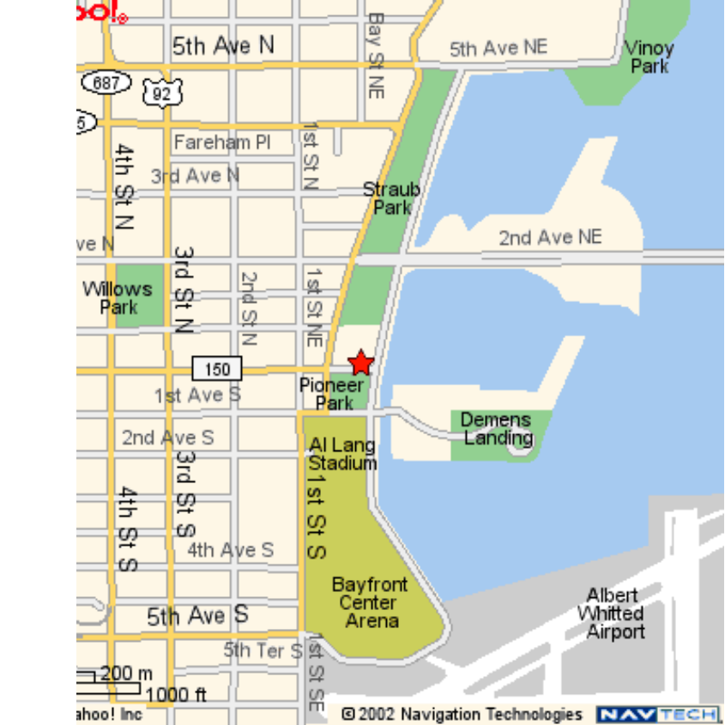
Medical Facilities:
The Bayfront Medical Center is located about one half mile from the SPYC. It is the area trauma center, and is a large urban medical complex with all of the associated facilities addition, Eckerd College, which is ten minutes away, operates a search and rescue training program, and could be asked to provide on-the-water emergency rescue support.

Security:
The St. Petersburg Yacht Club is a private facility with an attached parking garage. It is located in downtown St. Petersburg, surrounded by two parks, the municipal marina, and two hotels. The only residences in the immediate area are in several high-rise, luxury condo- minimum buildings. The St. Petersburg Sailing Center, shown below, is a city-owned, SPYC staffed and managed facility with its own parking lot, and its land access is controlled by a security fence and gate, which is locked when the facility is not open. When it is open, it is manned by St. Petersburg Yacht Club staff. City police patrol the area regularly. Security at either facility is not
a major concern.

Competitors:
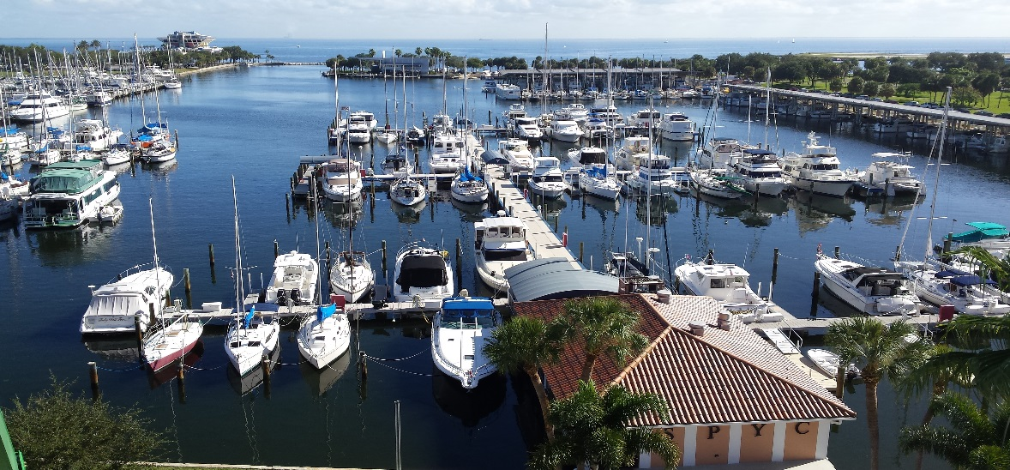
SPYC has held single class regattas with as many as 65+ boats.

Accommodations available for Sailors and Race Officials:
The City of St. Petersburg has many thousands of hotel rooms in all price categories. During the non-peak seasons, many rooms are available at bargain prices. Every major hotel and motel chain has a presence in St. Petersburg. There are three major hotels within walking distance of the sailing center and Club – Ponce DeLeon, Hampton Inn, and the Renaissance Vinoy.

In addition, many SPYC members have been generous in inviting race officials and competitors to stay in their homes. At recent high level events, all of the out of town officials and competitors were offered housing with Club members.

Travel Arrangements:
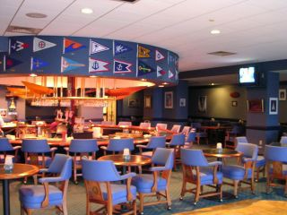
There are two major airports serving the Tampa Bay area. Tampa International Airport (TPA) is located in Tampa, and is within 30 minutes of the Club by car or van. TPA is served by most major airlines, and has all of the major auto rental companies right on the airport. The airport is served by a Super Shuttle service, which charges approximately $27 per person for the trip to the SPYC. Taxies are available, but are more expensive. However, three people sharing a taxi would be a bit less than the Shuttle for three people.

Local transportation will be provided for all officials
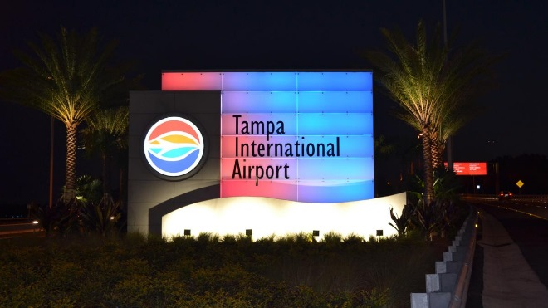
The Clearwater-St. Petersburg Airport (PIE) is located between Clearwater and St. Peters- burg, about 20 minutes from the Club. None of the major airlines operate from this facility, but several minor airlines and charter companies do.

Catering:
The SPYC is a large facility that includes two indoor dining rooms, an outdoor, waterfront dining facility, another on the upper deck that is open for breakfast and lunch, a lounge with its own waterfront deck where food is also served, and a number of private function rooms. The catering department can and has planned events for small, intimate groups and for gatherings of 1000 or more people. There is an extensive banquet menu which can serve any desire.
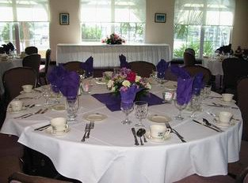

Other facilities:

There is a swimming pool on the upper deck of the clubhouse with an adjacent Tiki Bar. This deck overlooks the marina and is furnished with tables and chairs. It is an ideal place for an informal cookout.

A second clubhouse, SPYC at Pass-a-Grille, with dining facilities is located in that beach community at the Gulf of Mexico. There is an additional club-owned marina located three miles north of the main clubhouse on Snell Isle.

Race Management:
The SPYC runs major events every year during its primary racing season (October-April). We have a number of well-trained, highly experienced, race committee personnel. Who have organized numerous world and national events. We annually organize the Lightning and Thistle Midwinter Championships, the Sailing World St. Petersburg NOOD Regatta, and a number of PHRF and off shore events including our Annual International Race to Mexico (Regata del Sol al Sol). Other major events include the Snipe Women’s World Championship 2010, Sunfish State Championship 2011, Sunfish World Championship 2012, the Contender World Championship April 2012, the Pan AM game qualifier (mixed boat-Lightning’s) 2015, and will run the J70 Mid-Winter Championship 2016. In addition the SPYC has hosted several Match and Team Racing events – November 2000, we hosted the Rolex ISAF Women’s World Match Racing Championship and the Rolex Women’s Match (2002–2009 the Prince of Wales Bowl (US National Championship) in 1999, 2004 and 2009.
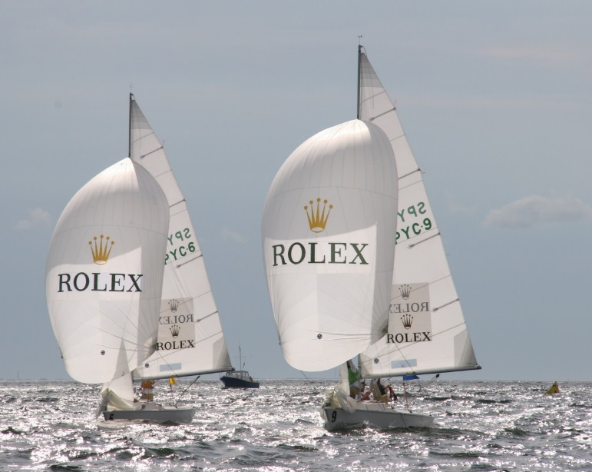
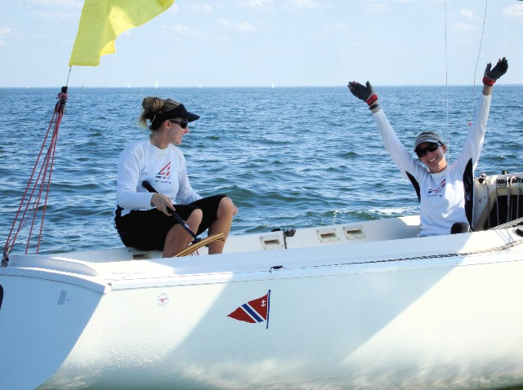
The Club has over 2000 members, many of whom are boat owners who are very generous about loaning their boats for race committee duty. [Boats are selected based on the needs of each event.] The Club owns a Dyer 29 lobster boat, which is frequently used as a mark boat. The club owns a large variety of course marks of all shapes and sizes.

Technical Delegate:
We will welcome a visit by the technical delegate at almost any time. When the decision has been made on who it is to be, we will be happy to determine a mutually acceptable time for his/her visit. We will gladly find accommodations in the home of one of our members. The same will apply during the event.
The St. Petersburg Sailing Center is fully accessible, including specially designed docks to accommodate disabled sailors – it is one of the premier centers for disabled sailing in the US, SPYC annually hosts Disabled/Open Regatta every December, and was the site of the 2003 Paralympics’ Team Trials.
Media:
The Tampa Times, a local daily newspaper, has a writer who covers local sailing events. The four major television networks (NBC, ABC, CBS and Fox) each have a local affiliate.
Internet connectivity for media updates is available at the SPYC. One large room in the main clubhouse, equipped with multiple telephone lines, will serve as the regatta office and media center. The Club is equipped with a dedicated photocopier. A fax machine is located in the next room.
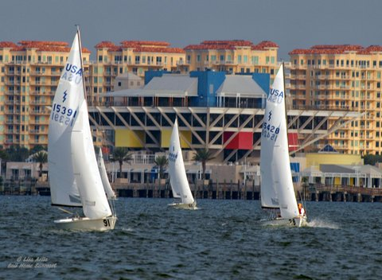
Communications:
The club has a website which will be used to post information about the event as it happens. We will post results from the race course on a flight by flight basis.
There is Wi-Fi connectivity available for all at the clubhouse and at the Sailing Center. There are two computers available in the club lobby for those who do not have their own.
There will be mobile telephones on all race committee boats and a directory will be supplied.
The race committee uses VHF radios and cellular telephones to communicate among themselves.
Facilities:
The Sailing Center has sufficient space for use by both officials and competitors. This includes a Jury room on the second floor. We will provide a semi-private area in the regatta office for the Technical Delegate.
Warm/Dry Areas: In this climate, that is not an issue. The Sailing Center includes indoor temperature controlled meeting rooms. The clubhouse is fully air-conditioned.
Changing Facilities: Both the Sailing Center and the SPYC have both men’s and women’s locker rooms with showers and changing facilities.
Financial:
We have not yet finalized a budget. We will make every effort to keep it as low as possible.
Spectators:
Public Accessibility: view the racing Every attempt will be made to provide a Spectator Boat. There is an electronic board in the Sailing Center that immediately posts the results while the Race Committee is still on the water.
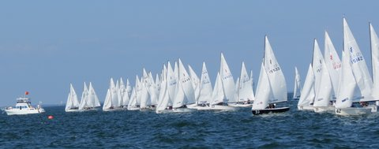

Hope to be SPYC BELOW!!!!! Hosting the J24 Class!!!
2015 Nationals – picture courteous of one of our SPYC sailors

